**POSV Bugs/Suggestions**

1. “Tobacco Type” and ”Frequency” both goes blank once user come back on same page.

Steps:

* Hit URL: <http://itsretirementuat.maxlifeinsurance.com/preissuance/mprobuyer?txnId=313130303030383730307c7c4d7c7c6d50726f707265>
* Click on “Next” till “Proposer Health Related Question”.
* Input “Tobacco Type” and ”Frequency” fields.
* Click on Next.
* Click on “Prev”, entered fields “Tobacco Type” and ”Frequency” are blank.
* User should be able to see what is fields values entered earlier.

**Screenshots:**

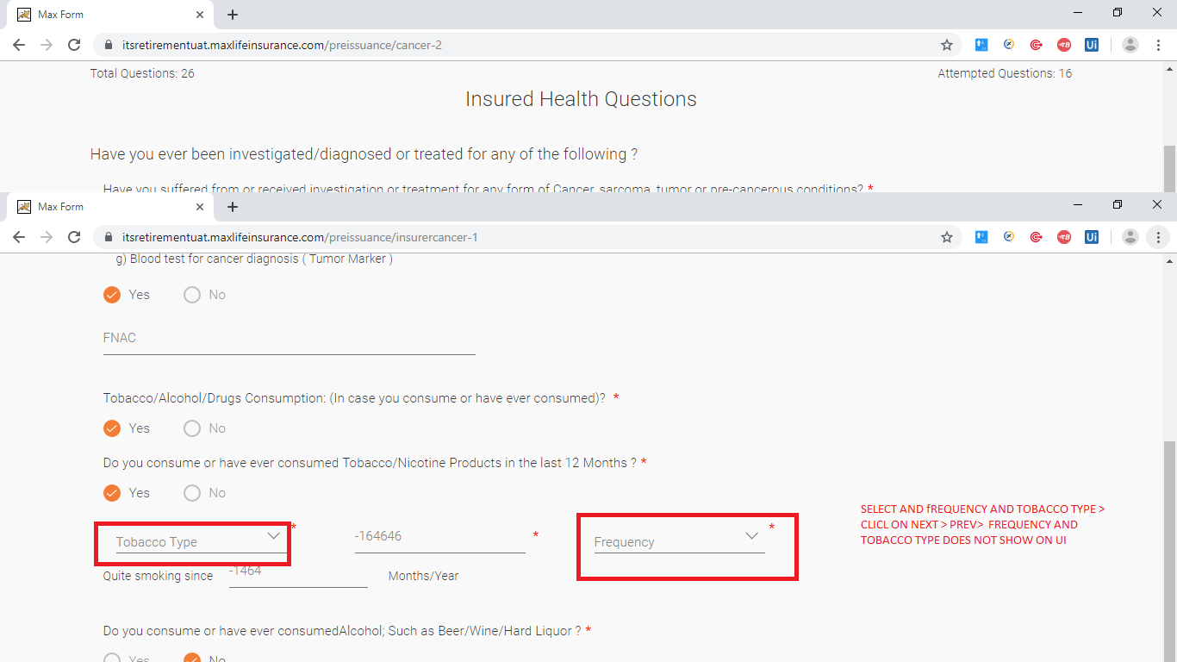

1. “Quantity/Day” and ” Quite smoking since” both accepts apart from Number and alphabets.

Steps:

* Hit URL: <http://itsretirementuat.maxlifeinsurance.com/preissuance/mprobuyer?txnId=313130303030383730307c7c4d7c7c6d50726f707265>
* Click on “Next” till “Proposer Health Related Question”.
* Input as (+,-,*,/) should not be allowed in , “Quite smoking since” and ”Quantity/Day” fields.

1. Typo issue.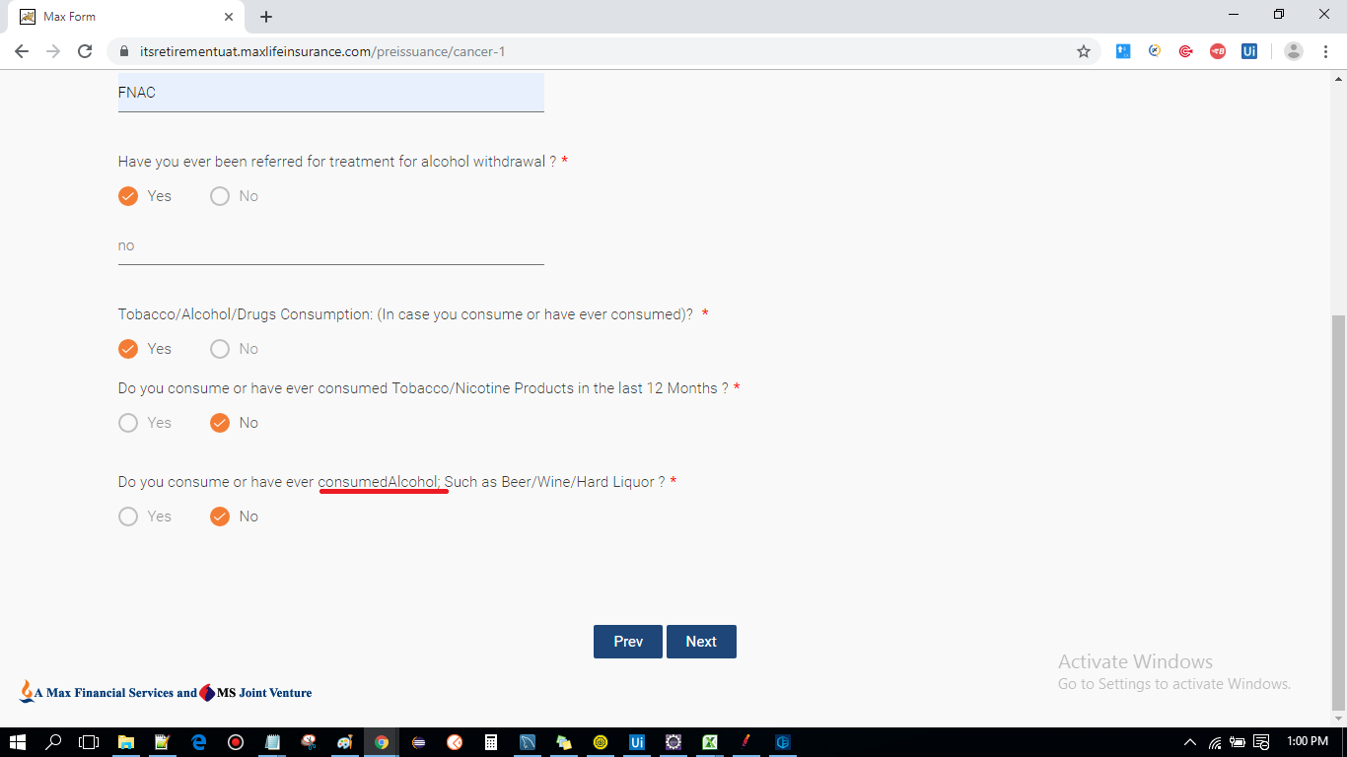
2. Typo issue.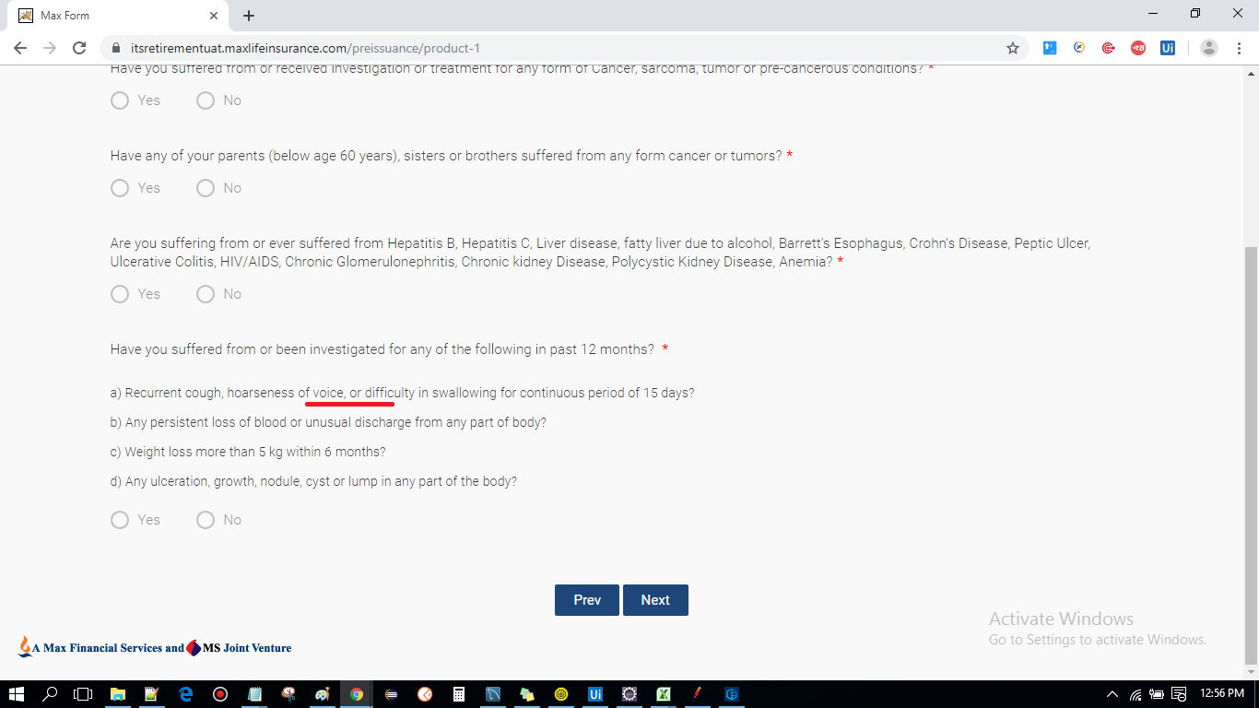
3. Width of blank space is more than usual.

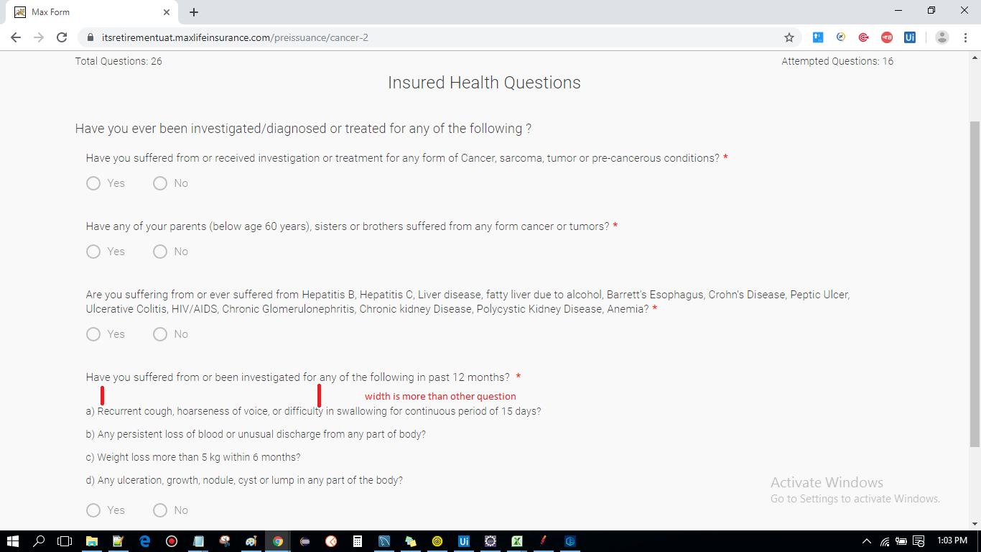

1. Capital/Small letter is not standard throughout the page.

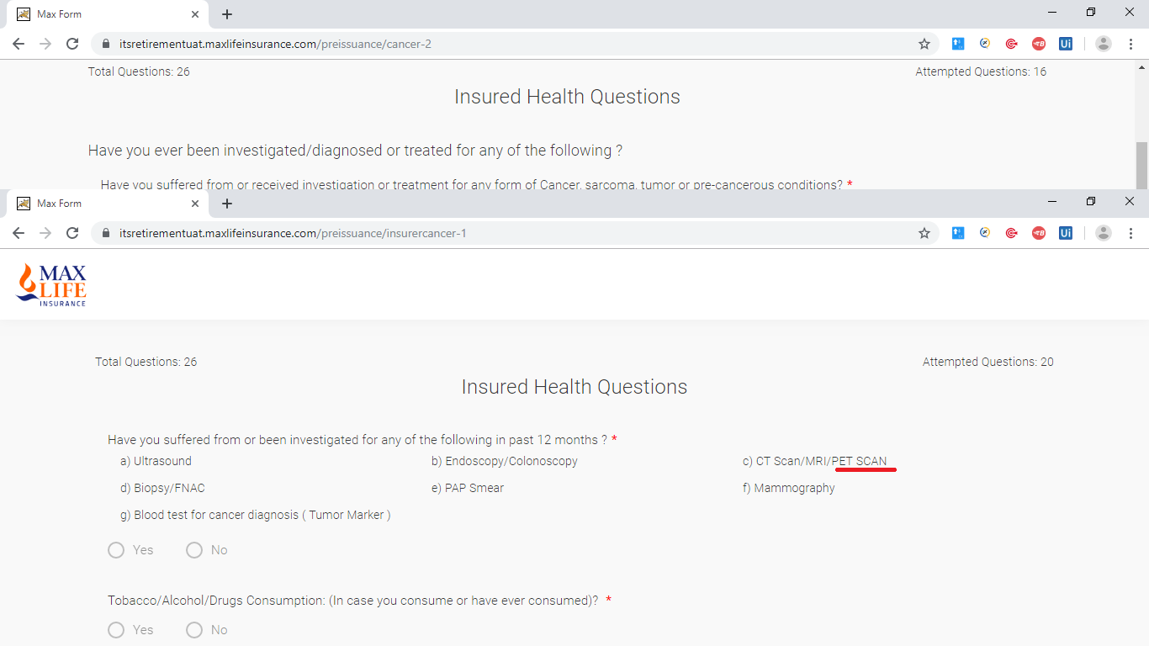

1. Typo issue.

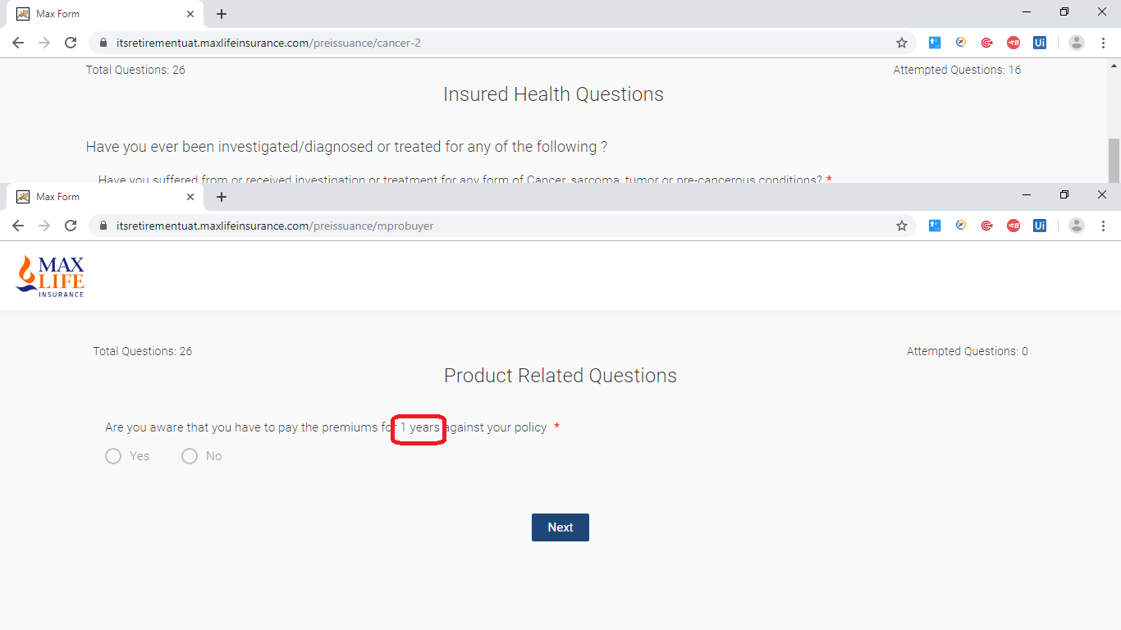

1. A. decimal values are of no use in case when there is not digits after decimal values even it seems confusing in first view.

b. Question does not has text case sensitivity.

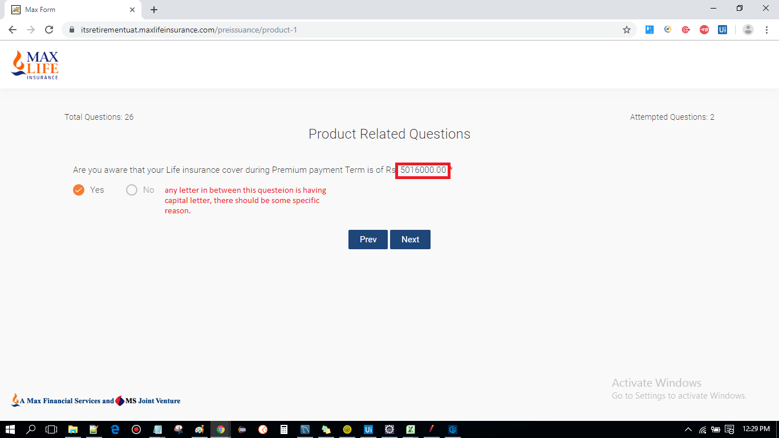

1. It is not readable to user end.

